Tutorial: Computer Overview.

1. Any computer system, large or small, can be represented by the four elements of an IPO model. Draw an IPO model; clearly label each of the four elements in your drawing.
2. One way to view an information technology system is to consider an IT system as consisting of four major components or building blocks. What are the four components of an IT system?

1. There are protocols that are not standards and standards that are not protocols. With the help of a dictionary, identify the differences between the definition of protocol and the definition of standard; then, identify a specific example of a standard that is not a protocol; identify a specific example of a protocol that is not a standard.

**Answers**

**Question 1**

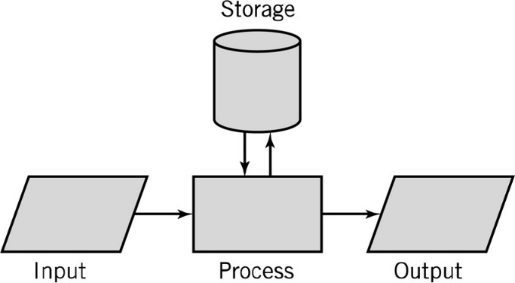

**Question 2**

*Hardware*

Processes data by executing instructions

Provides input and output

Control input, output and storage components

*Software*

Applications and system software

Instructions tell hardware exactly what tasks to perform and in what order

*Data*

Fundamental representation of facts and observations

*Communications*

Sharing data and processing among different systems

**Question 3**

**Standards** apply to every aspect of computing: hardware, software, data, and communications, the voltage of a power supply, the physical spacing of pins on a connector, the format of a file, the pulses generated by a mouse. Computer language standards, such as Java and SQL, allow programs written on one type of computer to execute properly and consistently on another, and also make it possible for programmers to work together to create and maintain programs. Similarly, data format and data presentation standards, such as the GIF and JPEG image format standard, the Unicode text format standard, and the HTML and XML Web presentation standards allow different systems to manipulate and display data in a consistent manner.

**Example** of a Standard that is not a Protocol: JPEG

**Protocols** define the specific agreed-upon sets of ground rules that make it possible for a communication to take place. Except for special applications, most computers perform their operations such that each hardware or software computer unit will understand what other computer units that they are connected with are saying. Protocols exist for communications between computers, for the communications between various I/O devices and a computer, and for communications between many software programs. A protocol specification defines such communication features as data representation, signaling characteristics, message format, meanings of messages, identification and authentication, and error detection. Protocols in a client-server system assure that requests are understood and fulfilled and that responses are interpreted correctly.

**Example** of a Protocol that is not a standard: SIP (Session Initiation Protocol)